**41014**

**Sensors and Control for Mechatronic Systems**

**Spring 2022**

**Project Proposal**

Project 3

Control and Grasping for DoBot Robot

**Group 15:**

Jun Kino 13363231  
Hoang Quan Do 13571955  
Liam Jiang 13043930

# Introduction

The aim of this project is to use data received from the sensors attached to the Dobot to grab and assort coloured object to its designated tray. The project task includes the utilization of Asus Xtion pro sensor to identify the colour and determine the paths required for the Dobot to perform the task.

# Scope

The project is defined as the range of tasks and delivery processes undertaken by the team to design a Dobot robot which grabs and assorts colour-oriented objects to its designated tray using Asus Xtion pro sensor.

Hence, the scope of the project is to demonstrate the following objectives:

* Obtaining data from Asus Xtion Pro sensor to monitor and control Dobot’s pose and movement
* Calibrating camera to verify object
* Collecting data from sensor to identify object shape, pose and colour
* Calculating and determine way points for Dobot
* Programming Dobot using ROS and Matlab to perform the tasks of sorting objects into following colour tray
* Documenting the project

Using Matlab, we can model the DoBot with the given parameters provided on UTS Canvas. UTS also allows for remote functioning of the physical DoBot via remotelabs, however connection to the UTS network is required for this to work.

# Deliverables

|  |  |
| --- | --- |
| **Deliverable** | **Due Date** |
| Submit Proposal | 31/08/2022 |
| Environment setup & initial setup for DoBot | 15/09/2022 |
| Mid-review report | 21/09/2022 |
| Develop RGB-D Camera setup code/Image Processing Code | 26/09/2022 |
| Develop movement code for DoBot | 30/09/2022 |
| Develop control feedback algorithm to adjust orientation and location of robot depending on error. | 7/10/2022 |
| Develop code for suction head to move items from point A to point B | 14/10/2022 |
| Finalise Code and Debugging | 18/10/2022 |
| Submit Code for project along with a video demonstrating the project | 19/10/2022 |
| Project teaser Presentation | 26/10/2022 |
| Final Report (Individual) | 27/10/2022 |

Table 1: Deliverables required for the DoBot Project

As shown in table 1, these are the main deliverables required for the success of this project. For DoBot Robot projects, the project can be done with the real robots in the labs as there is no simulator options available, hence the project needs to be conducted through remote labs (UTS, 2022). However, there is a model that can be created and plotted on Matlab that has different parameters and can be used to replicate the movements of the real DoBot.

The deliverables highlighted in yellow are self-imposed deliverables and will act as deadlines for each section of code. These do not need to be submitted individually but will attribute towards the final code due on 19/10/2022. As for the video demonstration, we can record the DoBot either on-site or via the remote lab and screen recording.

# Proposed Approaches

## Concept Design Map

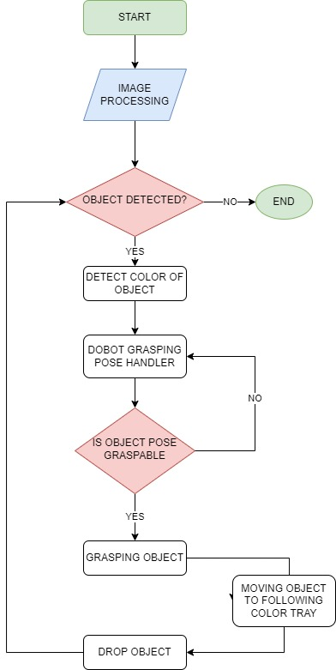

Figure 1: Concept Design Map for the DoBot task

## Approaches to the Project

### Image Processing

The sensor used in this project is an Asus Xtion Pro, which has an infrared sensor, a depth sensor, and a RGB-D camera sensor.

Image processing includes the tasks of:

* Using a camera or sensor for object recognition
* Collecting data from sensors to identify the object shape, pose, and colour
* Collecting data from the camera to identify 3D points on Dobot to identify the pose or position of the robot

### Color Detection

* The images of the objects are detected using an RGB-D camera.
* From Truecolour image (RGB image), calculate and identify the colour of the object using Matlab
* Using the colour data result to determine on which colour tray to put the objects

### DoBot Pose Handler

* Using data from the depth sensor to detect corners and edges to identify flat surfaces of the object so that Dobot can activate the pump to suction the object or pick up the object.
* Identify the centre point on the surface where Dobot's suction head makes contact.
* Identify the Dobot's head pose and use 3D projection to calculate the path from the suction head to the point on the object's surface where it can pick up the object.

# Task Division and Schedule

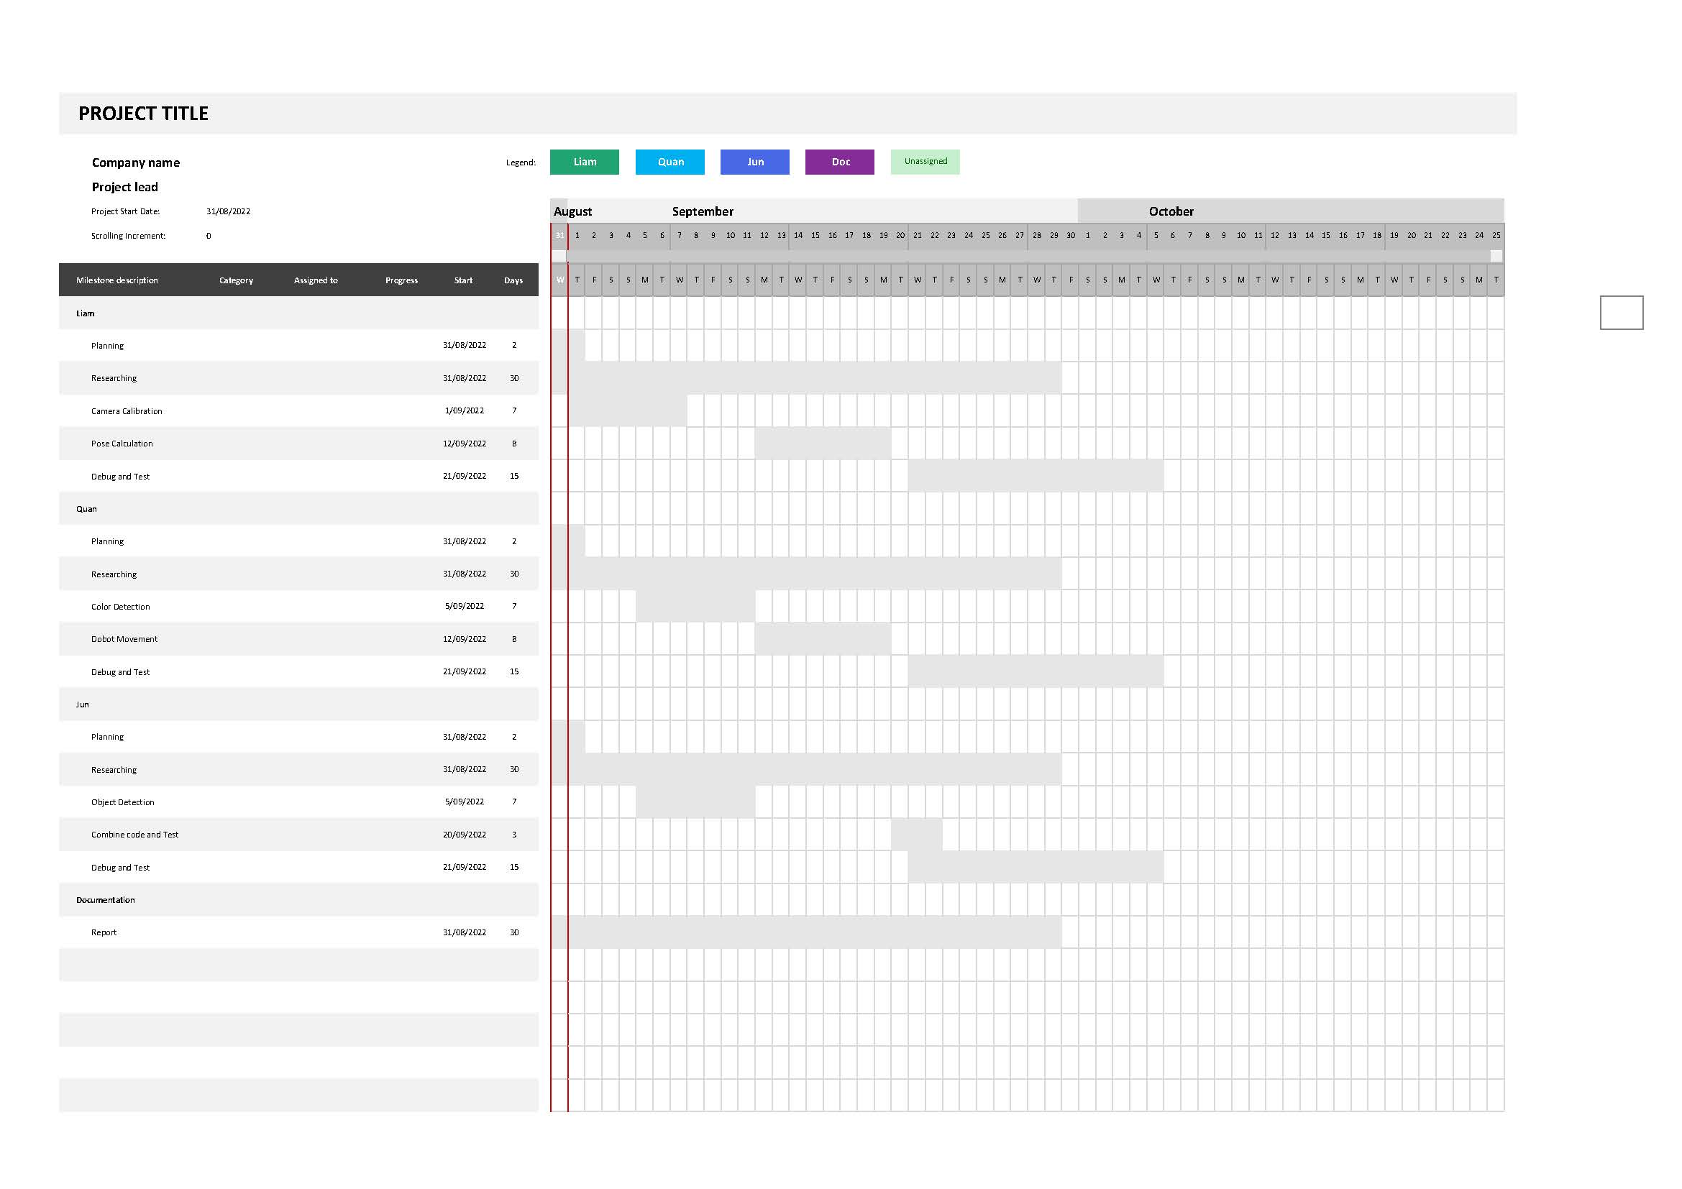

# References

University of Technology Sydney. (2022). *41014 Sensors and Control for Mechatronic Systems – Projects for Spring 2022.*  <https://canvas.uts.edu.au/courses/24760/files/3629330?module_item_id=1103852>

University of Technology Sydney. (2022). *Notes on the dobot real arm vs model arm.*  <https://canvas.uts.edu.au/courses/24760/files/3491687?module_item_id=1057733>

University of Technology Sydney. (2022). *Instructions For Using DoBot and RGBD Camera in the UTS Remote Labs.*  <https://canvas.uts.edu.au/courses/24760/files/3491732?module_item_id=1057735>

DOBOT. (2022). <https://en.dobot.cn/>

[Artcreation 3D Technology Limited](http://xtionprolive.com/index.php?route=common/home). *Xtion Pro Live*. <http://xtionprolive.com/asus-xtion-pro-live#:~:text=OVERVIEW,making%20user%20tracking%20more%20precise>.